SCOPE OF WORK (TEST GENERATOR)

1. Introduction
1.1 Purpose
The purpose of this document is to define the requirements for the development of a Test Generator web application for Oxford University Press (OUP) Pakistan. This application will serve teachers and schools with a platform to generate and administer tests.
1.2 Scope
The Test Generator Platform is designed to help teachers easily create and manage quizzes and tests in both printable and online formats. It will support various question types such as multiple choice, true/false, short answer, and subjective questions, allowing teachers to build assessments aligned with curriculum standards and learning outcomes.
The platform will include a question bank with tagging by grade, subject, book/title, chapter, topic, SLO and difficulty level, and offer features like randomization, and limited customization for the school (ability to upload their logo). Teachers will be able to export tests as PDFs or Word documents for offline use (printing), complete with answer keys.
For online delivery, the platform will provide a secure, web-based interface with auto-grading, manual grading (optional for subjective / comprehension questions), timers, and performance analytics. Additional features include detailed reporting. The solution will be delivered as a responsive web application with dashboards for teachers, students and admins, and will include documentation and training materials.

1.3 Definitions and Acronyms
- OUP: Oxford University Press
- B2B: Business-to-BusinessO: Student Learning Outcomes
- SRS: Software Requirements Specification
- QA: Quality Assurance
- Admin: OUP user with full system rights.
- Content Creator: OUP user responsible for question bank creation. E.g. editorial staff
- Content Manager: OUP user/School senior representative responsible for vetting the quality of content (questions) being published to the system and will be responsible for approving/rejecting the questions. e.g. Editorial lead. In case of the school, they will be limited to vetting the questions being put in their own school’s question bank.
- School Admin: School-level administrator.
- School Teacher: User responsible for test generation and student performance tracking.
- Soft Launch: The release of a new product or service to a restricted audience or market in advance of a full launch. This term is often interchangeable with beta/alpha releases.
- Version Releases: Ongoing development of the product which will enable / introduce new features to the product to keep the product upto date as per the market needs.
- Authentication: The process of identifying and establishing the user credentials.

2. Overall Description
2.1 Product Perspective
The Test Generator is a standalone web application. It will be a responsive, web-based platform accessible via a standard web browser either on a desktop or a mobile device.
2.2 Product Functions
The system will enable authenticated users to:
- Manage Users: Admin can create, delete, and manage user roles and rights.
- Create Question Banks: Content Creators and Content Managers can create and manage questions.
- Generate Tests: Teachers can create tests based on various criteria (by grade, subject, book/title, chapter, topic, SLO and difficulty level) in both online and offline (printable) modes.
- View Statistics: Admins, School Admins, and Teachers can view detailed statistics on user activity, test performance, and school performance.
- Student-facing Features: Students can attempt assigned online quizzes and view their performance and leaderboard.
2.3 User Characteristics
- Admin: Technically proficient, understands system architecture and business logic.
- Content Creator: Subject matter expert from OUP, knowledgeable in question formatting and creation.
- School Admin: Non-technical user, needs clear dashboards to monitor school-level performance.
- School Teacher: Proficient with the platform's core features, needs an intuitive interface for test creation and student tracking.
- Content Manager: Oup Indiviual/Senior teachers with elevated permissions to review and approve questions. In case of school they will only be able to approve questions for their respective schools.
- Student: Minimal technical expertise, needs a simple, clean interface for attempting quizzes.

2.4 Question Types
The following are the question types supported by the system, questions will be bi-lingual so that the quiz can be generated either in English or in Urdu language. Questions will need to be uploaded in the system in both languages.
- Offline Model
  - MCQ
  - Short questions
  - Fill in the blanks
  - True / False
  - Long questions
  - Labeling
  - Matching
- Online Model
  - MCQ
  - Short questions
  - Fill in the blanks
  - True / False
  - Long questions
  - Labeling
  - Matching
  - Drag and drop
  - Ordering / Sorting
3. System Features
3.1 Admin Features
- REQ-SA-001: The Admin shall be able to view a dashboard with overall system statistics.
- REQ-SA-002: The Admin shall be able to view individual school statistics.
- REQ-SA-003: The Admin shall be able to create, edit, and delete user accounts.
- REQ-SA-004: The Admin shall be able to manage user roles and rights.
3.2 Content Creator Features
- REQ-CC-001: The Content Creator shall be able to create and manage the central question bank.
3.3 School Admin Features
- REQ-SCH-001: The School Admin shall be able to view a dashboard with school-level statistics (e.g., active users, tests generated, student performance).
- REQ-SCH-002: The School Admin shall be able to filter statistics by grade, subject, and quiz title.

3.4 School Teacher Features
- REQ-T-001: The Teacher shall be able to view a dashboard with student performance statistics.
- REQ-T-002: The Teacher shall be able to generate tests in either online or offline mode.
- REQ-T-003: The Teacher shall be able to configure test parameters, including grade, subject, chapter, SLO, question type, number of questions, marks per question, and difficulty.
- REQ-T-004: The Teacher shall be able to create new questions individually or via bulk upload (CSV).
- REQ-T-005: The Teacher shall be able to submit created questions for approval by a Content Manager.
- REQ-T-006: The Teacher shall be able to view and edit questions in a preview mode before assigning/downloading, including shuffling questions and options, and changing marks.
- REQ-T-007: The Teacher shall be able to download tests in PDF or Word format with a separate answer key.
- REQ-T-008: The Teacher shall be able to assign online tests to students with a schedule and due date.
3.5 Content Manager Features
- REQ-R-001: The Reviewer shall be able to receive and approve or reject question creation requests from OUP(editorial)/Teachers.
3.6 Student Features
- REQ-S-001: The Student shall be able to view a dashboard with their quiz statistics.
- REQ-S-002: The Student shall be able to view and attempt assigned online quizzes.
- REQ-S-003: The Student shall be able to view their position on a leaderboard.

4. External Interface Requirements
4.1 User Interfaces
The application shall have a responsive, web-based user interface. The UI will adapt to different screen sizes to provide an optimal user experience on desktops, tablets, and mobile devices.
4.2 Software Interfaces
The system will need to generate downloadable files (PDF, Word).
4.3 Hardware Interfaces
No specific hardware interfaces are required. The application will run on standard computing devices.
5. Non-functional Requirements
5.1 Performance
- NFR-P-001: The system shall be able to handle a high volume of concurrent users, particularly during online test periods.
- NFR-P-002: The test generation process shall be fast, with a maximum response time of 5 seconds for fetching and displaying questions.
5.2 Security
- NFR-S-001: User authentication and authorization shall be role-based, ensuring each user can only access features and data associated with their role.
- NFR-S-002: All sensitive data, including user credentials and data, shall be encrypted both in transit and at rest.
5.3 Reliability
- NFR-R-001: The system shall have high uptime (90%) and be available 24/7, excluding planned maintenance.
5.4 Scalability
- NFR-S-001: The system architecture shall support horizontal scaling to accommodate the growth from the feedback received from the user and as per market needs.

6. Workflows
6.1 Admin
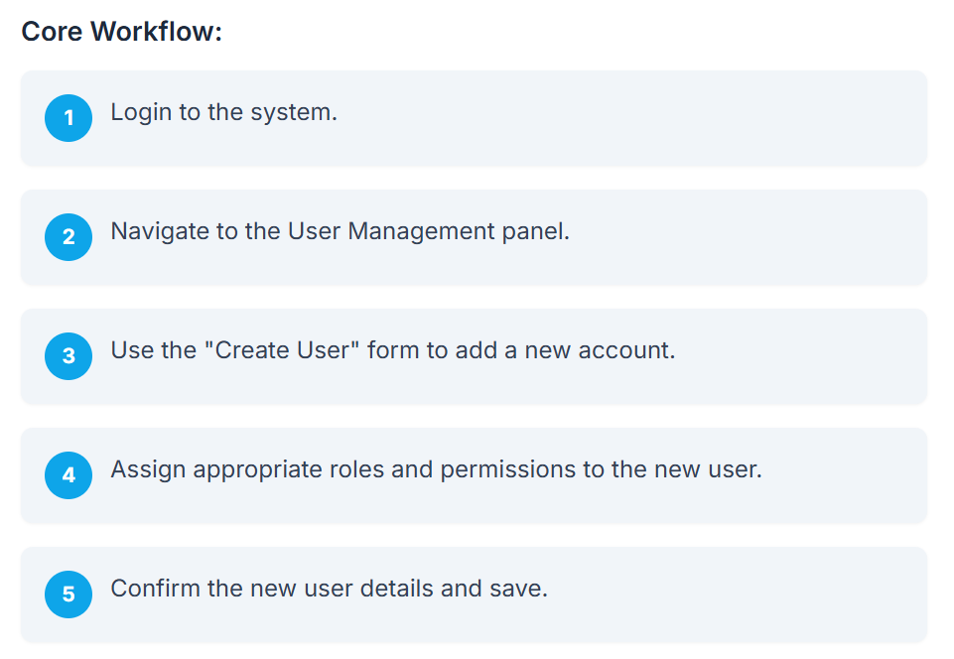
6.2 Content Creator
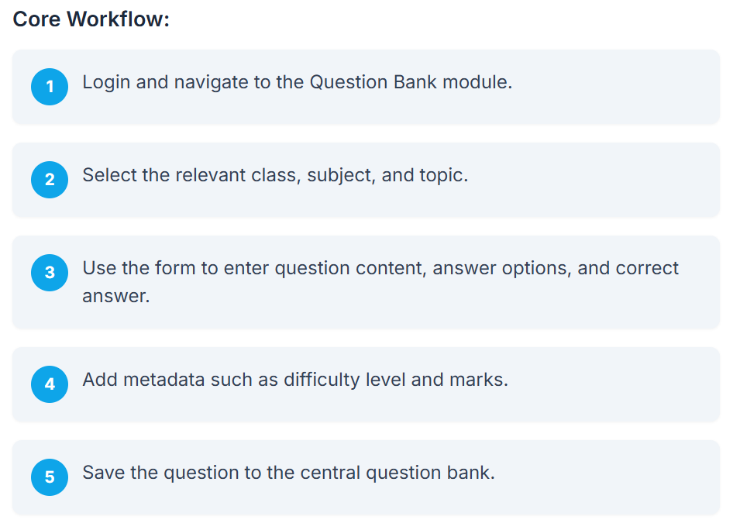

6.3 School Admin
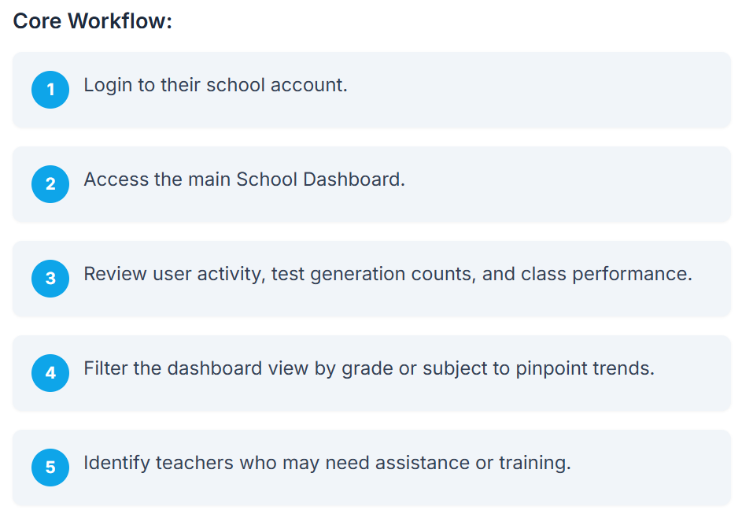

6.4 School Teacher
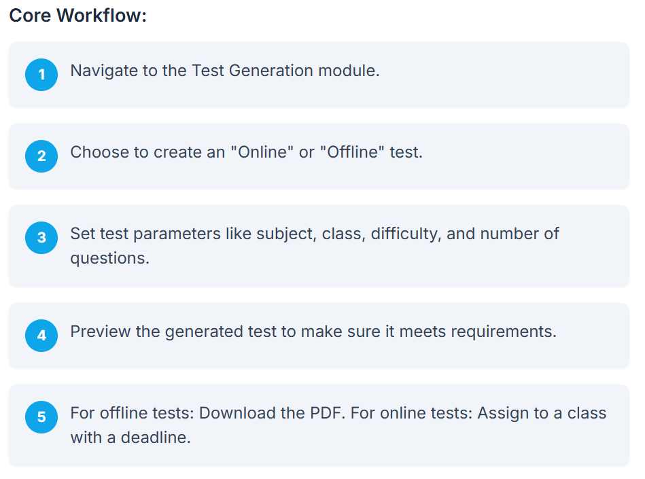
6.5 Content Manager
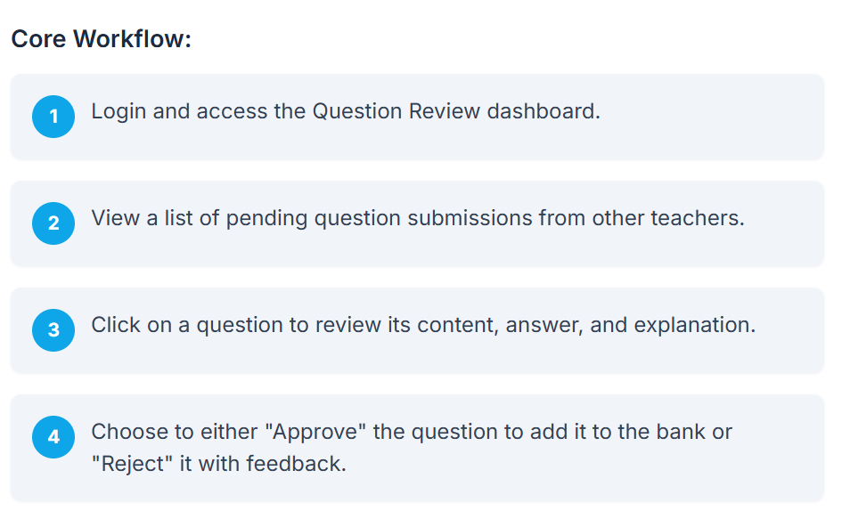

6.6 Student
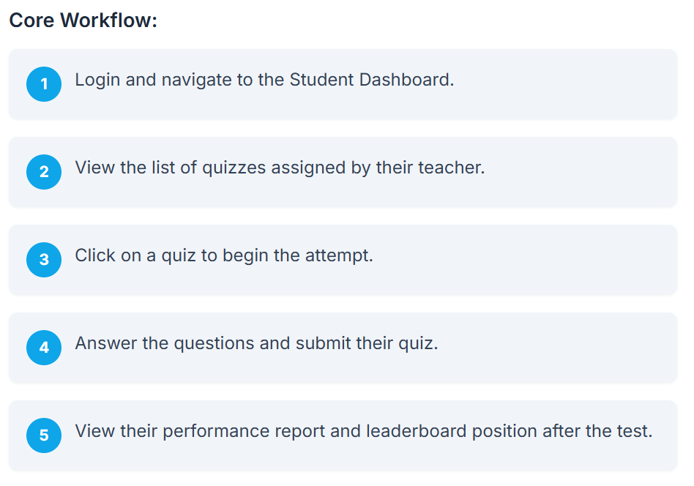
7. Development Approach
This section outlines the modern agile development process for the OUP Test Generator, we will be working in sprints with each sprint launching a predefined feature discussed in the SOW. This approach prioritizes UI/UX design before coding to ensure a user-centric final product.
7.1 Requirement Gathering
The process begins with a deep dive into the business goals, user needs, and technical constraints. This phase involves stakeholders, product managers, and end-users to create a definitive requirements document and user stories.
7.2 UI/UX Design Phase
This is where the look and feel of the application are crafted.
UX Design: focuses on user flows, information architecture, and wireframes.
UI Design: focuses on the visual aspects, including colors, typography, and interactive elements. This phase is critical because it guides all subsequent coding efforts and ensures alignment with user expectations.
7.3 Frontend & Backend Development
This is the core coding phase.
Developer will translate the UI designs into interactive interfaces and build the server-side logic, databases, and APIs.

7.4 Testing
The application will undergo rigorous testing, including Unit Testing, Integration Testing, UI Testing, and User Acceptance Testing (UAT). This ensures the app works as intended, is bug-free, and meets all specified requirements before launch.
7.5 Deployment & Launch
The final tested version of the application will be deployed to the production environment. Continuous Integration and Continuous Deployment (CI/CD) pipelines will be used to automate this process, leading to a smooth launch.
7.6 Maintenance & Iteration
Based on user feedback, analytics, and performance metrics, the team will continue to make updates and improvements, ensuring the application remains a valuable tool.
8. Question Bank Scope (For Soft Launch)
Detail | Target
Subjects | English, Math, Science
Books per Subject | 2 or 3 top selling titles of each subject
Chapters per Book | All
Questions per Chapter | 50 (20 easy, 20 medium, 10 hard)
Total per Book | 1500 – 2500 questions per book
Total Bank (MVP) | 4,500 to 7,500 questions

9. Growth Roadmap
- Phase 1 (Beta Announcement/UAT, Sales Conference 2025)
  - 3 subjects, 1 book
  - Full Offline version with capabilities of creating and printing papers.
  - Will include the standard software beta disclaimer: Beta version being shown is under development and the primary function of this beta testing agreement is to obtain feedback on software performance and the identification of any bugs. The product functionality as well as look and feel are subject to change.
  - Internal UAT with a beta group of users to ensure all the functionalities of the product are working as advertised for the soft launch.
- Phase 2 (Beta 1/Soft Launch, January 2026):
  - 3 subjects, 2 to 3 books each
  - Offline version with capabilities of creating and printing papers.
  - 4-5 schools per region
- Phase 3 (Launch, March 2026):
  - 7 subjects (English, Math, Science, History, Geography, Computer Science, Urdu)
  - 2 to 3 books each
  - Offline and Online functionalities
- Phase 4: (Sept 2026): All 7 subjects (Top-20)

